Azure Load Balancer —
Definition:
Azure Load Balancer (LB) is a Layer-4 (TCP/UDP) load balancer that distributes incoming traffic across Azure Virtual Machines (VMs) within a region.
Azure Load Balancer ek Layer-4 (Transport Layer) service hai jo TCP/UDP traffic ko multiple backend servers (VMs) ke beech distribute karta hai.
Yeh incoming traffic ko balance karta hai taki load ek VM par na aaye — sabhi VM ka proper utilization ho.
Kaise kaam karta hai?
Architecture:
- Client ka request LB ke Frontend IP par aata hai.
- LB ke pass Backend Pool (VMs) ka group hota hai.VNET NEED TO SELECT .-->(NIC OR IP ADDRESS)
- LB Health Probe se VM ki health check karta hai (Alive hai ya nahi).
- Load Balancing Rules ke basis par traffic kisi healthy VM ko forward karta hai.

Types of Azure LB:
LB Type | Use Case | Example
Public Load Balancer | Internet se traffic distribute karna | Web server, API server, RDP/SSH via Public IP
Internal Load Balancer | VNet ke andar private traffic distribute karna | Internal Application, Database Server, App tier

Important Concepts:
- Frontend IP: Load Balancer ka public ya private IP
- Backend Pool: VMs jo traffic receive karengi
- Health Probe: TCP/HTTP ping jo VM ki availability check karta hai
- Load Balancing Rule: Traffic ka rule (protocol, port etc.)

Kab Use Karte Hai Azure LB?
Jab aapko chahiye:
- High Availability
- Scalability
- Application ko multi VM par run karna hai
- Auto-healing environment
- Failover solution chahiye

Real Time Example:
Public LB
Website hosted on 3 VMs → Public LB → Evenly distribute traffic to 3 VMs.
Internal LB
App tier aur DB tier ke beech private communication → Internal LB → Distribute query to backend servers.

Interview Tip:
Hamesha bolna:
"Azure Load Balancer is used for distributing inbound and outbound traffic across multiple healthy virtual machines to ensure high availability and fault tolerance at Layer 4."

Types of Azure LB:
Type | Purpose
Public Load Balancer | Distributes internet traffic to VMs
Internal Load Balancer | Distributes traffic within VNet (Private)

Key Features:
- Layer-4 load balancing (TCP/UDP)
- High Availability & Scalability
- Health Probes to check VM availability
- NAT Rules for VM access (like RDP/SSH)

Load Balancing Rules:
- Distributes traffic based on front-end IP, protocol, port, and backend pool.

Use Cases:
- Internet-facing Applications (Public LB)
- Internal Applications (Internal LB)
- Application HA & Failover
- Load Balancing across Availability Zones
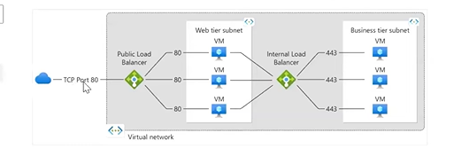
BASIC LB – FREE , STANDARD – CHARGABLE

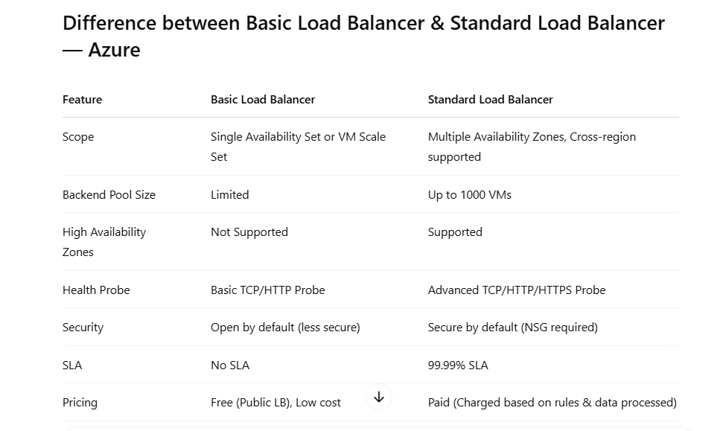
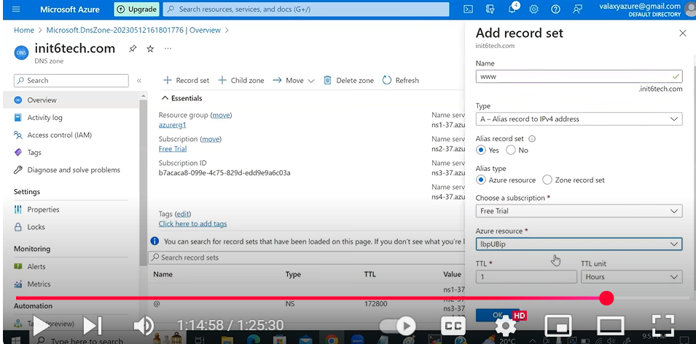

📘 Azure Front Door –
🔹 1. Introduction
Azure Front Door ek global, layer-7 (HTTP/HTTPS) load balancer + CDN + WAF service hai.
👉 Yeh users ko nearest edge location se connect karta hai for low latency + high performance

🔹 2. Key Features
- Global load balancing 🌍
- SSL termination
- Path-based routing
- Web Application Firewall (WAF)
- CDN capabilities (caching)
- Automatic failover

🔹 3. How It Works (Flow) 🔥
User Request → Nearest Edge POP → Front Door → Backend (App/VM/API)
👉 Microsoft backbone network use hota hai (fast + secure)

🔹 4. Core Components
🔹 1. Frontend Host
- Public URL (example: app.azurefd.net)

🔹 2. Backend Pool
- Backend resources ka group
- Example: App Service, VM, AKS
👉 Azure Kubernetes Service bhi backend ho sakta hai

🔹 3. Routing Rules
- Decide karta hai request kaha jayegi
- Path-based routing possible
👉 Example:
- /api → backend1
- /web → backend2

🔹 4. Health Probes
- Backend health check karta hai
- Unhealthy backend ko traffic nahi deta

🔹 5. Load Balancing Types
- Latency-based routing (nearest region)
- Priority-based failover
- Weighted routing

🔹 6. Security Features 🔐
- HTTPS (SSL termination)
- Web Application Firewall (WAF)
- DDoS protection (Azure integrated)
- Custom rules (block IP, rate limit)

🔹 7. Caching (CDN Feature)
- Static content cache karta hai edge pe
- Faster response time
👉 Example: images, CSS, JS

🔹 8. Use Cases
- Global web applications
- Multi-region apps
- API acceleration
- Disaster recovery (failover)

🔹 9. Front Door vs Other Services 🔥
👉 vs Azure Application Gateway
- Front Door → Global
- App Gateway → Regional

👉 vs Azure Traffic Manager
- Front Door → HTTP/HTTPS routing
- Traffic Manager → DNS-based routing

🔹 10. Performance Benefits
- Low latency (edge locations)
- Fast failover
- Optimized routing

🔹 11. Important Interview Points
- Layer 7 load balancer
- Global service (not region-specific)
- WAF integrated
- Supports path-based routing
- Uses Microsoft global network

🔹 12. Real-Time Scenario
👉 Global e-commerce app
- Users worldwide
- Front Door route karega nearest region me
- Agar region down → auto failover

🔹 13. Common Interview Questions
- Azure Front Door kya hai?
- Front Door vs Traffic Manager
- Front Door vs Application Gateway
- Routing kaise hoti hai?
- WAF ka role kya hai?

🔥 Final Interview Answer
👉 “Azure Front Door is a global layer-7 load balancer that provides intelligent routing, SSL termination, caching, and WAF security to deliver high performance and availability for web applications.”

📘 Azure Front Door – Section Wise Q&A
🔹 1. Basic Q&A
Q1. Azure Front Door kya hai?
👉 Azure Front Door ek global Layer-7 load balancer hai jo HTTP/HTTPS traffic ko optimize karta hai aur nearest backend pe route karta hai.

Q2. Yeh kaunse layer pe kaam karta hai?
👉 Layer 7 (Application Layer)

Q3. Iska main use kya hai?
👉 Global apps ke liye low latency + high availability + secure routing

🔹 2. Intermediate Q&A
Q4. Front Door ke components kya hain?
👉 Frontend host, Backend pool, Routing rules, Health probes

Q5. Backend pool kya hota hai?
👉 Backend resources ka group (VM, App Service, Azure Kubernetes Service etc.)

Q6. Routing rules kya karti hain?
👉 Decide karti hain ki request kis backend ko jayegi (path-based routing possible)

🔹 3. Routing & Load Balancing
Q7. Kaun-kaun se routing methods hote hain?
👉
- Latency-based
- Priority-based (failover)
- Weighted routing

Q8. Health probe ka role kya hai?
👉 Backend ki health check karta hai aur unhealthy instance ko remove kar deta hai

🔹 4. Security Q&A 🔐
Q9. Front Door me security kaise hoti hai?
👉 HTTPS, WAF, DDoS protection

Q10. WAF kya karta hai?
👉 Malicious traffic (SQL injection, XSS) block karta hai

🔹 5. Comparison Q&A 🔥
Q11. Front Door vs Azure Traffic Manager?
👉
- Front Door → HTTP/HTTPS routing
- Traffic Manager → DNS level routing

Q12. Front Door vs Azure Application Gateway?
👉
- Front Door → Global
- App Gateway → Regional

🔹 6. Scenario-Based Q&A
Q13. Global users hain, app multi-region me deployed hai – kya use karoge?
👉 Azure Front Door use karunga for latency-based routing

Q14. Ek region down ho gaya – kya hoga?
👉 Front Door automatically healthy backend pe traffic shift karega

Q15. Static content fast serve karna hai?
👉 Front Door caching enable karunga

Q16. Different path ke liye different backend?
👉 Path-based routing configure karunga

🔹 7. Advanced Q&A
Q17. SSL termination kya hota hai?
👉 Front Door pe SSL decrypt hota hai, backend ko HTTP me forward hota hai

Q18. Session affinity support karta hai?
👉 Haan (cookie-based affinity)

Q19. Custom domain kaise configure karte ho?
👉 DNS mapping + SSL certificate bind

Q20. Performance kaise improve karta hai?
👉 Edge locations + Microsoft backbone network

🔹 8. Troubleshooting Q&A
Q21. Backend hit nahi ho raha – kya check karoge?
👉
- Backend health
- Routing rules
- Health probe status

Q22. High latency issue?
👉
- Backend region mismatch
- Caching disabled
- Network latency

Q23. 502 / 503 error aa raha hai?
👉
- Backend down
- Wrong configuration
- Probe failure

🔹 9. DevOps / Real Scenario
Q24. CI/CD setup me kaise use karoge?
👉
- Multi-region deployment
- Blue-Green / Canary routing
- Traffic shifting using weighted routing

Q25. DR architecture kaise banega?
👉
- Multiple regions backend
- Priority routing (primary + secondary)

🔹 10. Rapid Fire 🔥
Q26. Layer kaunsi?
👉 Layer 7
Q27. Global ya regional?
👉 Global
Q28. WAF support karta hai?
👉 Haan
Q29. DNS based hai?
👉 Nahi (HTTP routing hai)

🔥 Final Interview Answer
👉 “Azure Front Door is a global layer-7 load balancer that provides intelligent routing, caching, SSL termination, and WAF security to deliver high performance and availability for global applications.”

📘 Azure Front Door –
🔹 1. Introduction
Azure Front Door ek global, layer-7 (HTTP/HTTPS) load balancer + CDN + WAF service hai.
👉 Yeh users ko nearest edge location se connect karta hai for low latency + high performance

🔹 2. Key Features
- Global load balancing 🌍
- SSL termination
- Path-based routing
- Web Application Firewall (WAF)
- CDN capabilities (caching)
- Automatic failover

🔹 3. How It Works (Flow) 🔥
User Request → Nearest Edge POP → Front Door → Backend (App/VM/API)
👉 Microsoft backbone network use hota hai (fast + secure)

🔹 4. Core Components
🔹 1. Frontend Host
- Public URL (example: app.azurefd.net)

🔹 2. Backend Pool
- Backend resources ka group
- Example: App Service, VM, AKS
👉 Azure Kubernetes Service bhi backend ho sakta hai

🔹 3. Routing Rules
- Decide karta hai request kaha jayegi
- Path-based routing possible
👉 Example:
- /api → backend1
- /web → backend2

🔹 4. Health Probes
- Backend health check karta hai
- Unhealthy backend ko traffic nahi deta

🔹 5. Load Balancing Types
- Latency-based routing (nearest region)
- Priority-based failover
- Weighted routing

🔹 6. Security Features 🔐
- HTTPS (SSL termination)
- Web Application Firewall (WAF)
- DDoS protection (Azure integrated)
- Custom rules (block IP, rate limit)

🔹 7. Caching (CDN Feature)
- Static content cache karta hai edge pe
- Faster response time
👉 Example: images, CSS, JS

🔹 8. Use Cases
- Global web applications
- Multi-region apps
- API acceleration
- Disaster recovery (failover)

🔹 9. Front Door vs Other Services 🔥
👉 vs Azure Application Gateway
- Front Door → Global
- App Gateway → Regional

👉 vs Azure Traffic Manager
- Front Door → HTTP/HTTPS routing
- Traffic Manager → DNS-based routing

🔹 10. Performance Benefits
- Low latency (edge locations)
- Fast failover
- Optimized routing

🔹 11. Important Interview Points
- Layer 7 load balancer
- Global service (not region-specific)
- WAF integrated
- Supports path-based routing
- Uses Microsoft global network

🔹 12. Real-Time Scenario
👉 Global e-commerce app
- Users worldwide
- Front Door route karega nearest region me
- Agar region down → auto failover

🔹 13. Common Interview Questions
- Azure Front Door kya hai?
- Front Door vs Traffic Manager
- Front Door vs Application Gateway
- Routing kaise hoti hai?
- WAF ka role kya hai?

🔥 Final Interview Answer
👉 “Azure Front Door is a global layer-7 load balancer that provides intelligent routing, SSL termination, caching, and WAF security to deliver high performance and availability for web applications.”

Azure Traffic Manager —
Definition:
Azure Traffic Manager is a DNS-based global load balancer that distributes user traffic to the most appropriate endpoint based on routing methods.

Key Features:
- DNS-based traffic distribution
- Improves performance & availability
- Routes traffic across Azure regions or external endpoints
- Monitors endpoint health

Routing Methods:
Method | Purpose
Performance | Lowest latency-based routing
Priority | Primary-Secondary (Failover setup)
Weighted | Traffic distribution using weight
Geographic | Region-specific traffic routing
Multivalue | Returns multiple healthy endpoints
Subnet | IP range-based routing

Use Cases:
- Global load balancing
- Multi-region application availability
- Disaster recovery
- Geo-based content delivery

Limitation:
- DNS-based (only provides endpoint IP)
- Actual data traffic does not pass through Traffic Manager
1. Azure Endpoints
- Ye endpoints Azure ke hi resources hote hain.
- Support karta hai:
  - Azure App Services (Web Apps)
  - Azure Cloud Services
  - Azure Virtual Machines (VMs) with public IP addresses
  - Azure Public IP addresses
- Ye endpoints automatically integrate ho jaate hain Traffic Manager ke sath jab aap select karte ho Azure resource.

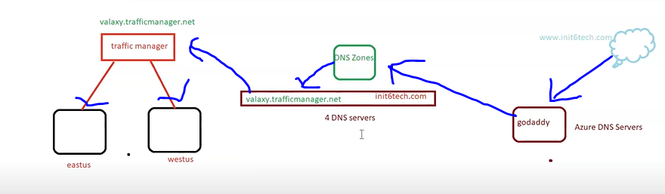

Create a traffic manager
Add endpoints .
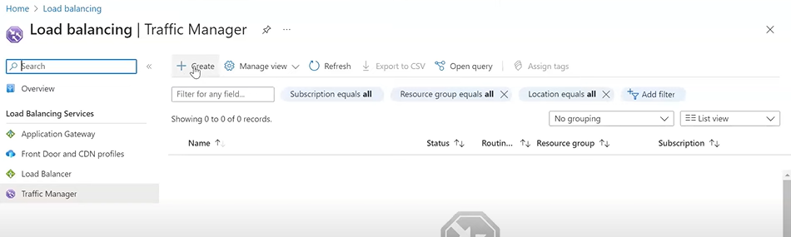
Create two vm in two different region CONFIGURE NGINX IN BOTH . configure DNS NAME FOR BOTH VM .
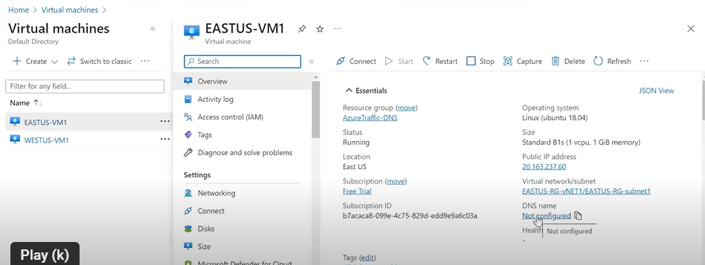
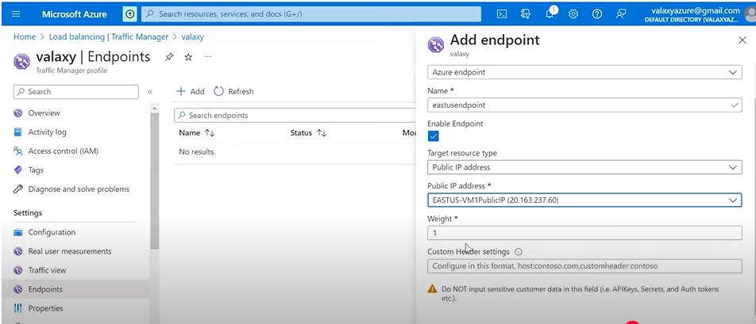
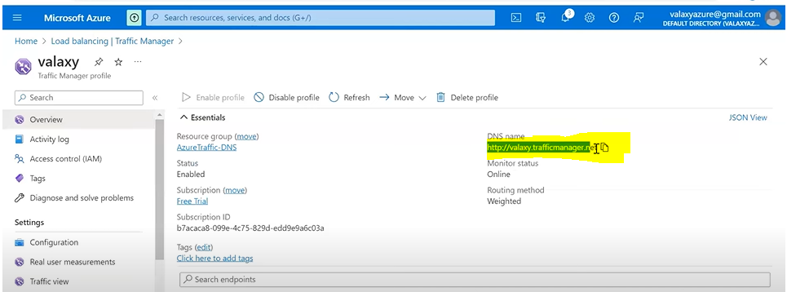
DNS NAME INTO BROWSER AND WE ABLE TO SEE NGINX PAGE.BUT we donot want traffic manger.net in domain we want some good name ,so we buy domain from godaady.
Create DNS zone on azure portal .the purchased domain name from godaddy is used in name section while creating DNS ZONE .
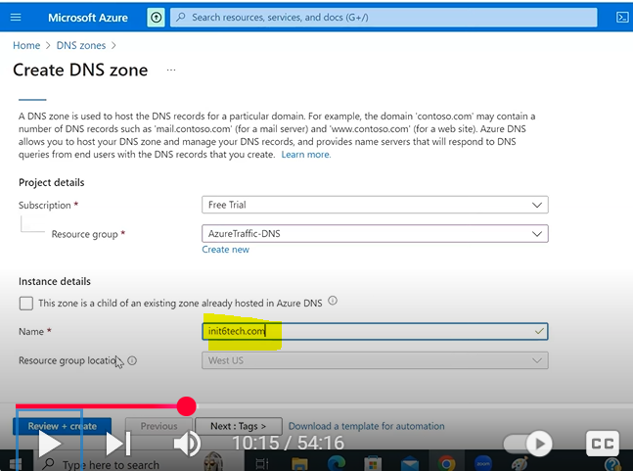
FOUR NS CREATED IN DNS ZONE .

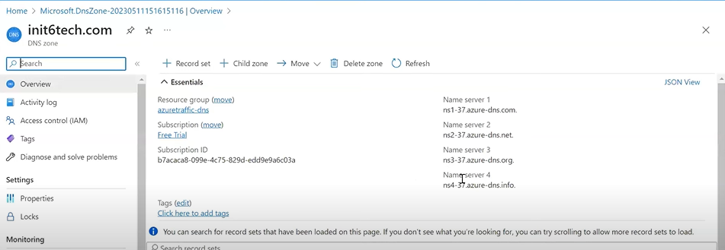
LOGIN GODADDY and update NS with created ns in DNS ZONE .
NOW go in azure DNS and add record with cname.

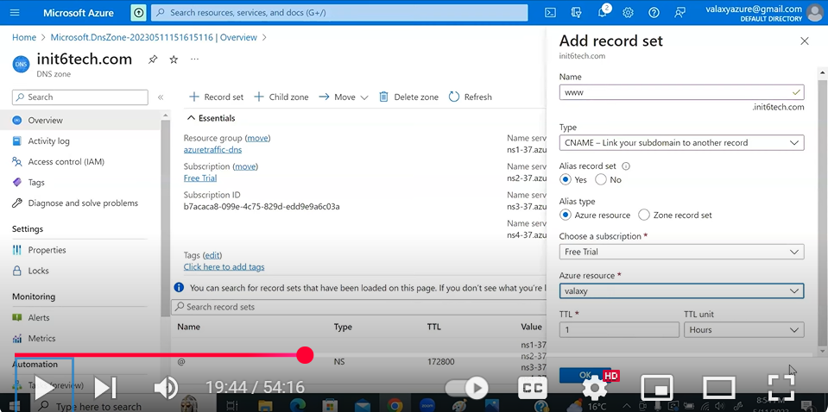

Difference: -
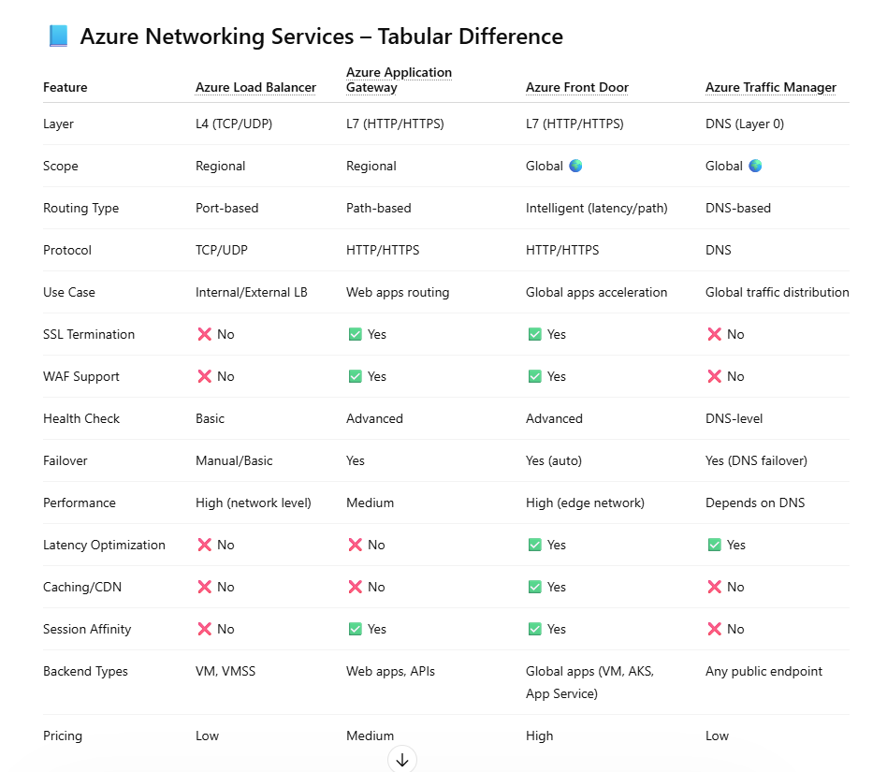
🔥 Quick Summary (Interview बोलने वाला)
👉
- Load Balancer → L4, simple traffic distribution (VM level)
- Application Gateway → L7, web routing + WAF (regional)
- Front Door → Global L7, CDN + WAF + low latency
- Traffic Manager → DNS-based global routing

🔥 One-Line Use Case
- LB → “VM traffic balance karna hai”
- App GW → “Web app + WAF chahiye”
- Front Door → “Global app + performance + security”
- Traffic Manager → “DNS level global routing”

